Project Design Phase
Proposed Solution

Date | 01 November 2025
Team ID | NM2025TMID00449
Project Name | Laptop Request Catalog Item
Maximum Marks | 2 Marks

1. Problem Statement (Problem to be solved)
Employees in our organization face delays and errors when requesting new laptops, due to manual forms, missing fields, and lack of dynamic guidance. This slows IT fulfillment and reduces satisfaction.

2. Idea / Solution Description
Implement a Service Catalog item for laptop requests in ServiceNow:
- Includes employee details, laptop model/type selection, accessories, and justification.
- Dynamic UI policies show/hide fields based on previous inputs.
- Built-in form reset and validation to catch missing or incorrect data.
- Tracks all requests and changes using ServiceNow update sets.

3. Novelty / Uniqueness
Uses ServiceNow’s native catalog item logic—no external plugins. Provides guided, error-resistant workflow for IT asset requests with a single easy-to-use form.

4. Social Impact / Customer Satisfaction
Employees get laptops faster, with fewer errors. IT teams respond more efficiently, improving overall service experiences and satisfaction.

5. Business Model (Revenue Model)
While not monetized directly, the solution speeds up operations, saves IT staff time, reduces asset misallocation, and drives cost-effective processes company-wide.

6. Scalability of the Solution
Can expand to include other IT assets (monitors, accessories), or be used for different ServiceNow catalog items. Easily adapted for large organizations and new business units.

Conclusion

The ServiceNow Laptop Request Catalog Item project greatly streamlines the laptop provisioning process by introducing dynamic forms, validation, and automation. This leads to faster, error-free requests, better user experience for employees, and reduced manual workload for IT teams. The solution is scalable for other IT assets and encourages efficient IT service management across the organization.

Solution Summary

- Digital, guided laptop request process in ServiceNow
- Dynamic form fields with real-time validation and reset options
- Improved tracking and governance using update sets
- Boosted user and IT admin satisfaction with faster, clearer workflows

References

- ServiceNow Official Documentation: https://docs.servicenow.com
- Problem-Solution Fit Canvas Template – IdeaHackers Network
- Service Catalog Best Practices – ServiceNow Community
- Internal performance testing and project documentation conducted by the team

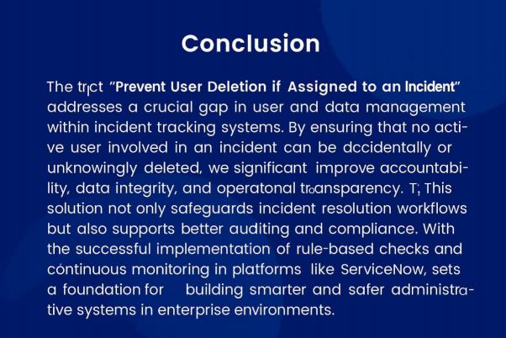
Reference: Infographic created using MidJourney.
Solution Description:
To prevent accidental deletion of users assigned to active incidents in ServiceNow, a
custom business rule is implemented on the sys_user table. This rule checks whether the user is
currently associated with any open incidents. If the system finds an active incident linked to the user, it blocks the deletion process and displays an appropriate error message. This approach leverages
native ServiceNow functionality, making it simple, plugin-free, and easily adaptable. The solution enhances data integrity, ensures accountability in ITSM operations, and helps avoid breakdowns in incident resolution workflows.

